10. Significant Separation of Submaxima in Orientation Data sets
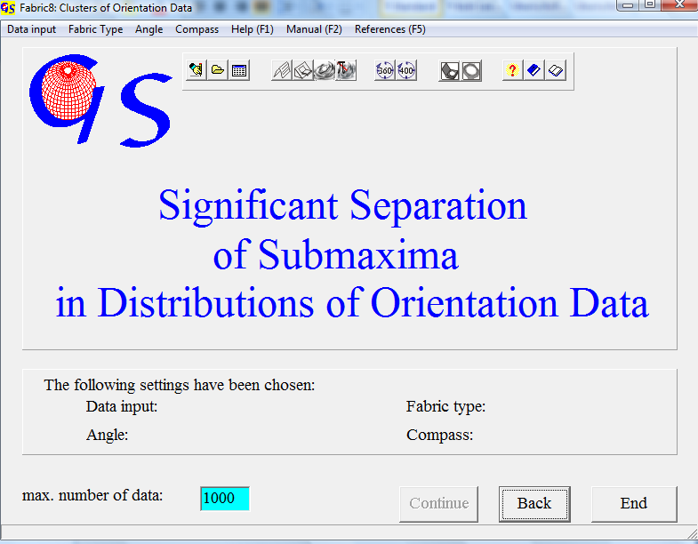
Fig. 1

Program 10 (Fig. 1) finds clusters in distributions of orientation data and tests their significance ( WALLBRECHER, 1986).

Menus on the starting form and data input are the same as in the programs 3, 4, 8, and 9.
The program finds the clusters as follows: A small circle is drawn around each data point. The radius of this circle is derived from a certain contour line level (multiple of even distribution). The circle becomes smaller with increasing contour line levels. All Data points which have overlaping circles belong to the same cluster. Clusters with less than four points are eliminated. The resulting clusters are tested for significant separation. The criterion is an overlap of the spherical apertures of the clusters. Clusters are not significantly separated, if they overlap. Data of overlaping clusters are put in a common ‘pooled groop’.
Fig. 2 shows the evaluation of the data set which has also been used in Program 4 and 8 (Fig.4). The separation was carried out on the level of 3 multiples of even distribution.
Three clusters with significant separation were found. The graph shows these clusters as small circles around their centres of gravity. The outer red circle is the spherical aperture (see program 8) which is a spherical measure for deviation. The inner small circle is the cone of confidence for the centre of gravity of the cluster. (here for a confidence of 99%). Separation is significant because the spherical apertures do not overlap.

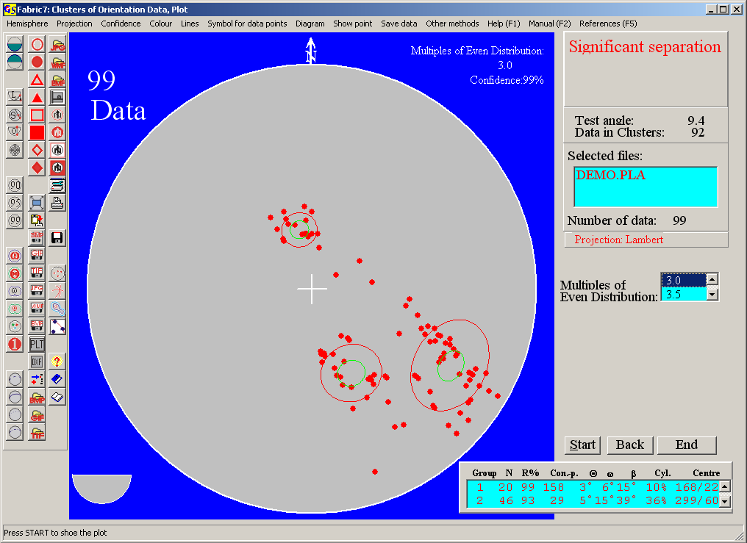
Fig. 2

In this diagram 93 data are in clusters, the rest consists of isolated data, outside the clusters. A cluster must contain at least four data. The statisical measures (for explanation see program 8) are listed in the table in the left lower corner. The menu bar is the same as in the previous programs. The contour level on which significant separation shall be tested can be chosen in the scroll list “Multiples of Even Distribution”.
Fig. 3 shows the clusters on the level of nine multiples of even distribution. Two clusters overlap, their data are put together in a pooled group. The statistic parameters of this pooled group are also listed. The black circles are the spherical aperture and the cone of conficence of the pooled group.
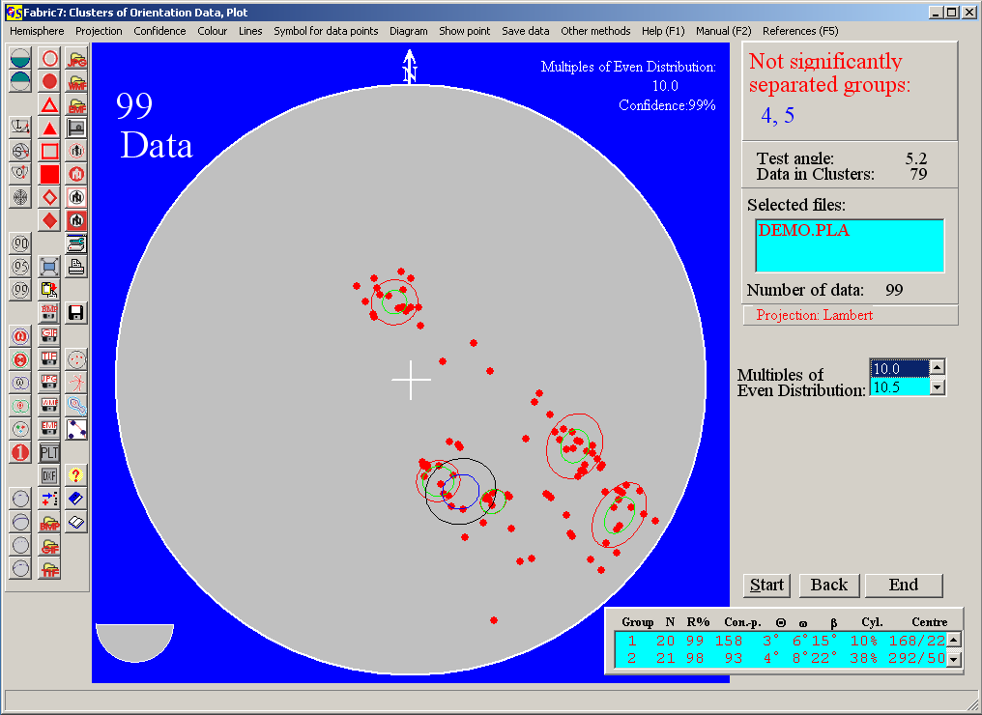
Fig. 3

The menu “Show point“ is described in the program “Contour lines.

With the menu "Other methods" you jump to the other programs which use orientation data.

Menus, not mentioned here, are described in program 3.

